SCO Project – Style and Convention

Text
Music and Music Text Font: Norfolk
Text Font: Noto Serif

Page and Staff
Page Size: Typically A3
Staff Size: Typically 4.1mm. Ok to reduce on certain pages to allow more music to fit (nothing smaller than 3.7mm). Overall staff size can also be reduced to 4mm or increased to 4.4mm where applicable. Any other sizes, please check with me.

Margins
Refer to the screenshot below.

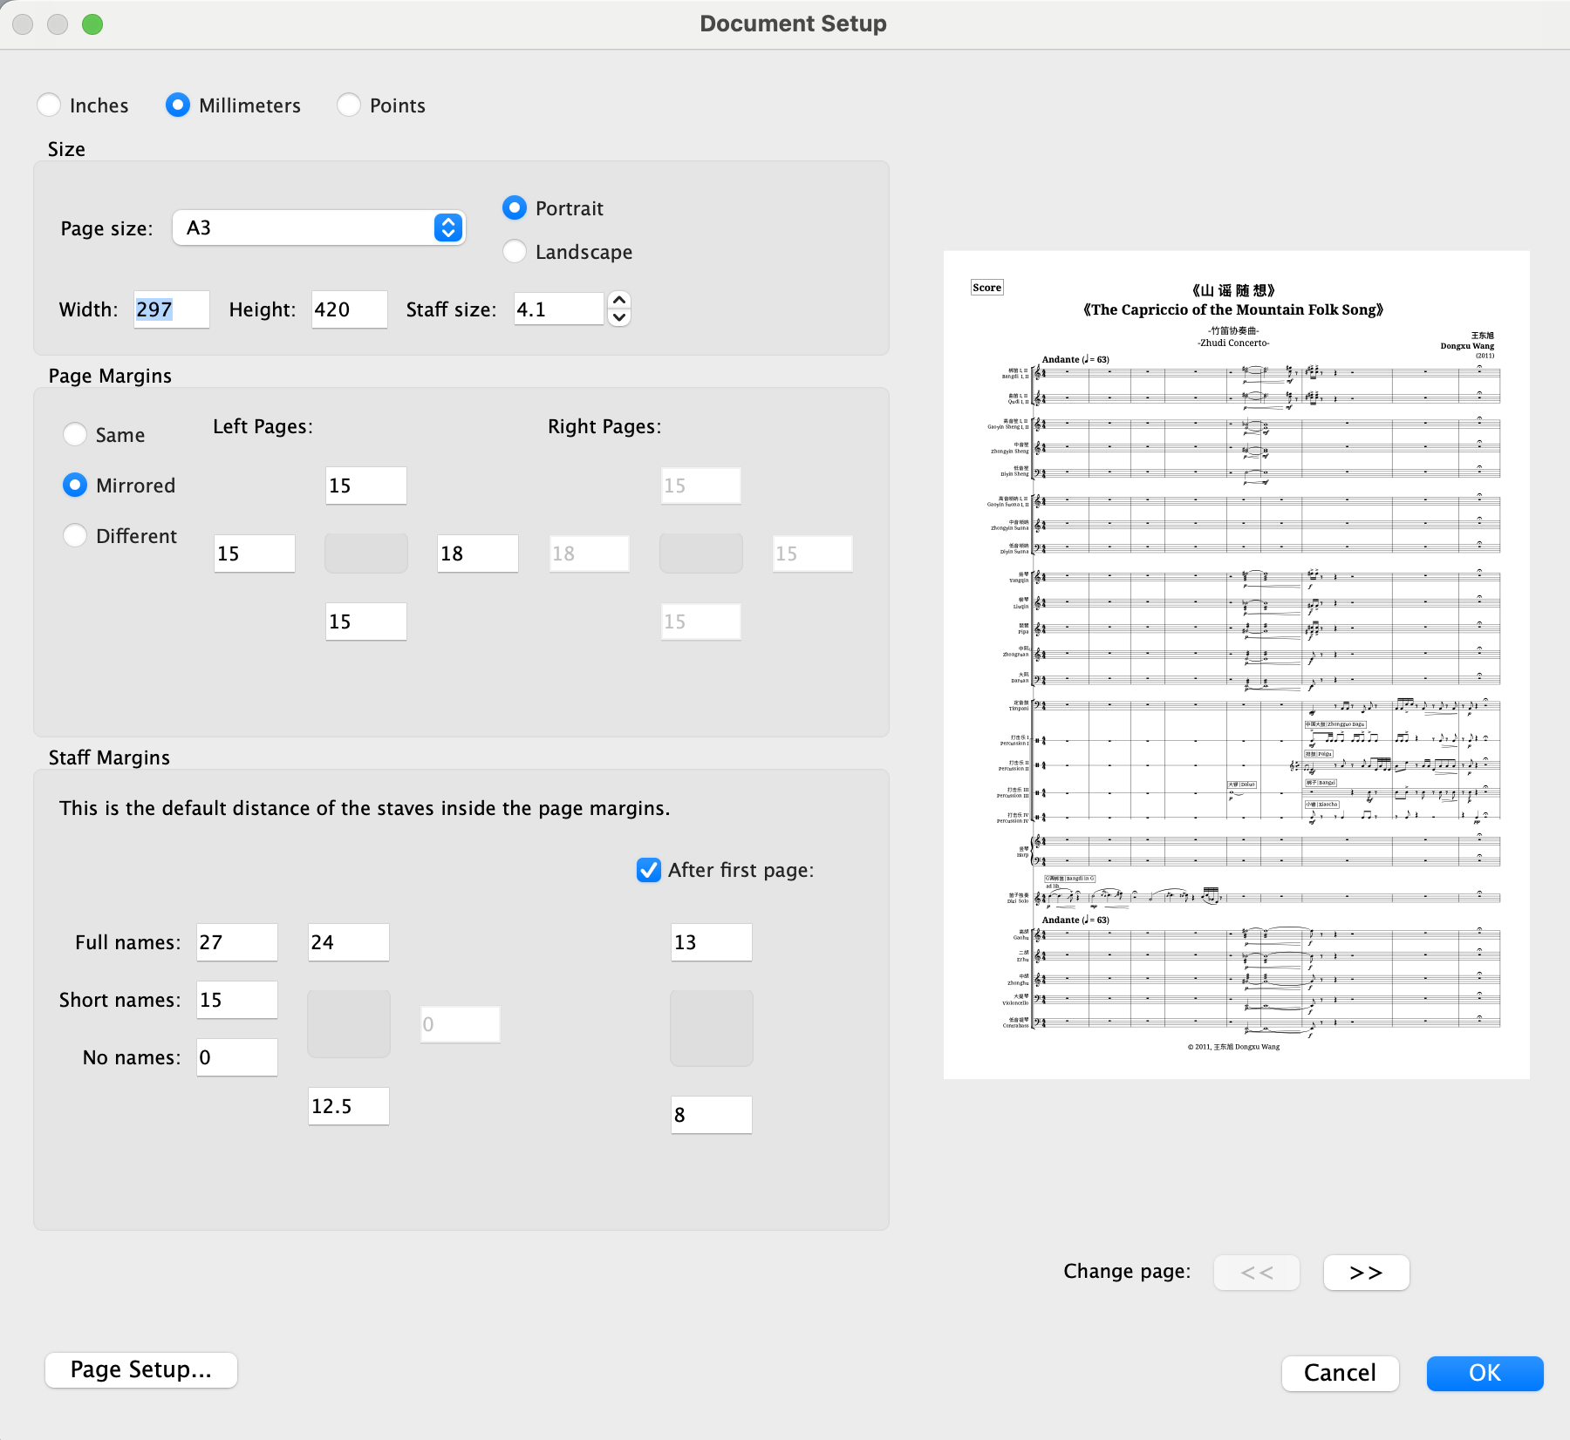

Text Sizes
Note: Size in parts doesn’t matter here.
Additionally, some text styles like Title/Composer also have some vertical positioning. Refer to the 6th piece for that.
Further – text sizes may also change if the score margin/page size is substantially different. Check with me if you have any questions. (Essentially, making things look aesthetic and standardized within the context of each score is more important than standardization across multiple scores).

Title: 20 (Absolute)
Subtitle: 13.5
Composer: 11
Composition Year: 9
Instrument Name at Top Left (i.e. ‘Score’): 14.5 (May remove this in the future but keep for now).
Tempo: 12.5. However, note that it uses a blend of fonts – Noto Serif for the text, but Norfolk for the brackets.

Example setup below. Please add all of these details into the info and use wildcards.

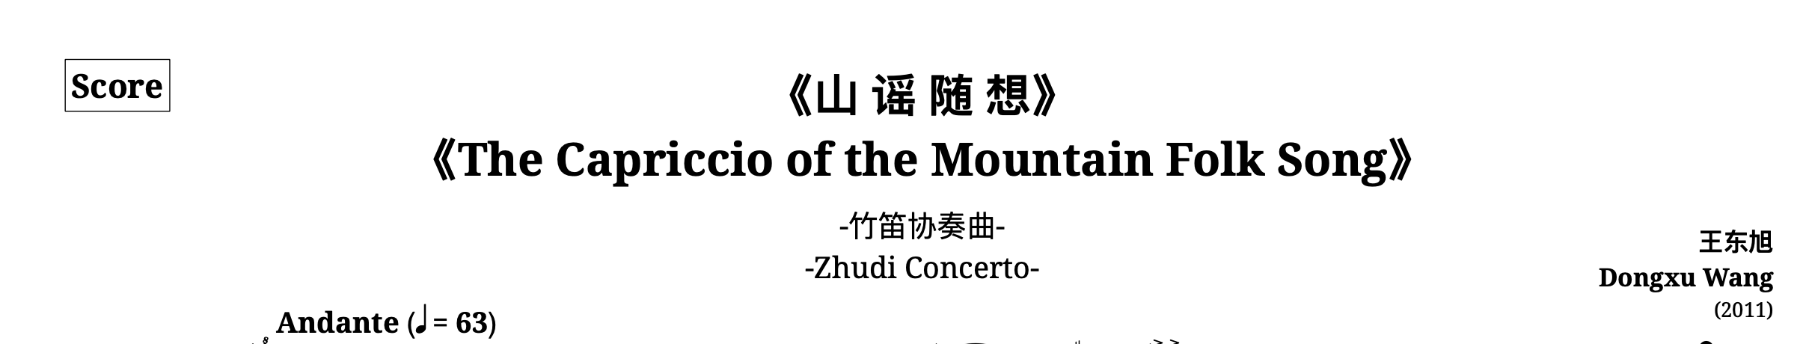

Instrument Name: 7

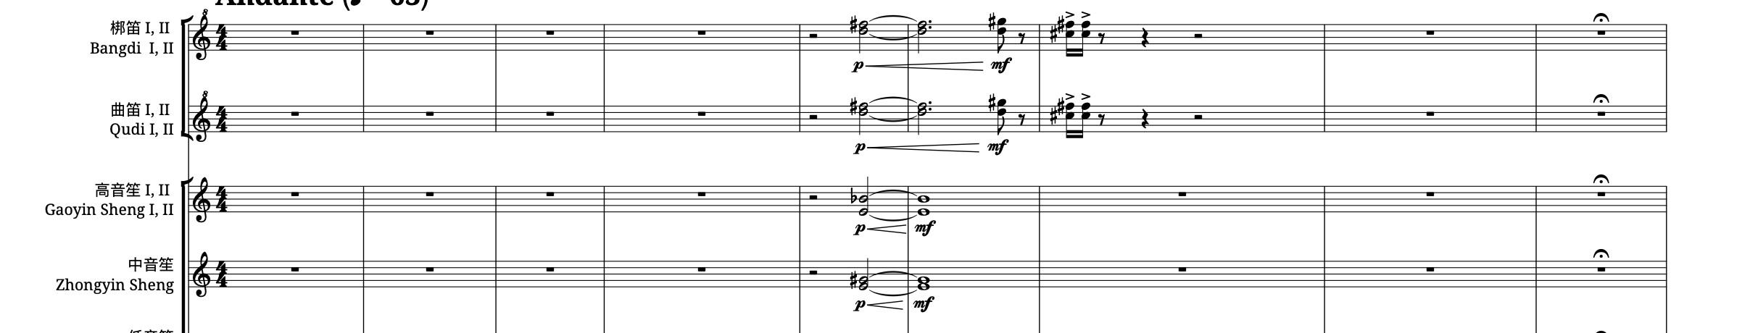
For instruments, Chinese name should appear above, with the English name below.

Percussion Instruments
Main Instrument/Player Name: 7
Percussion Name: 6

For percussion instruments excluding Timpani, keep the percussion player at size 7, while the actual current percussion name should be at size 6. (See example below). For percussion, we will skip out on the English name given the limited space.

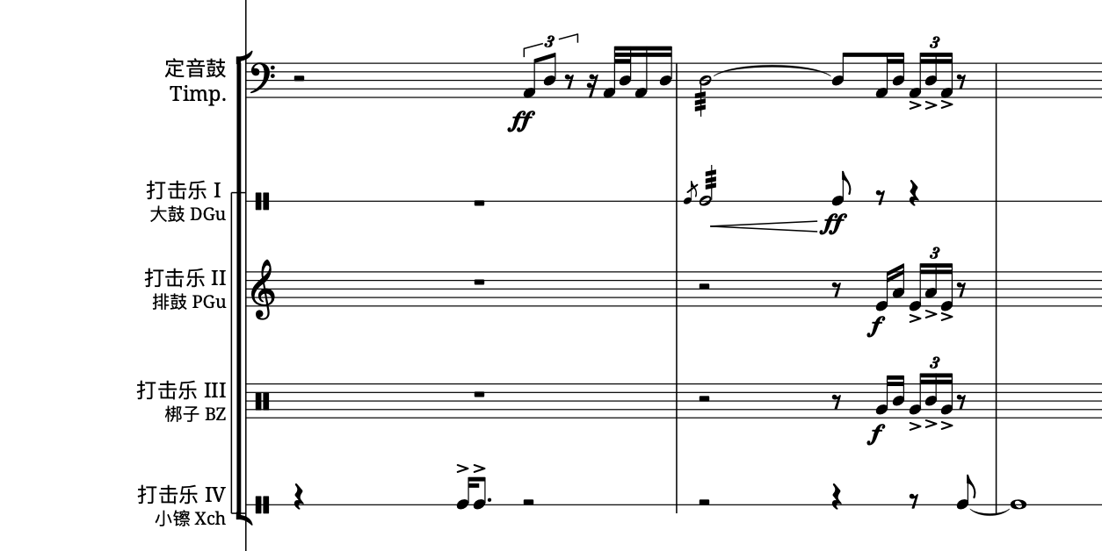

For percussion instrument changes, use boxed changes. Change the ‘instrument change’ font to have a boxed border (details below). If any of the existing changes don’t use this font, please change to this font.
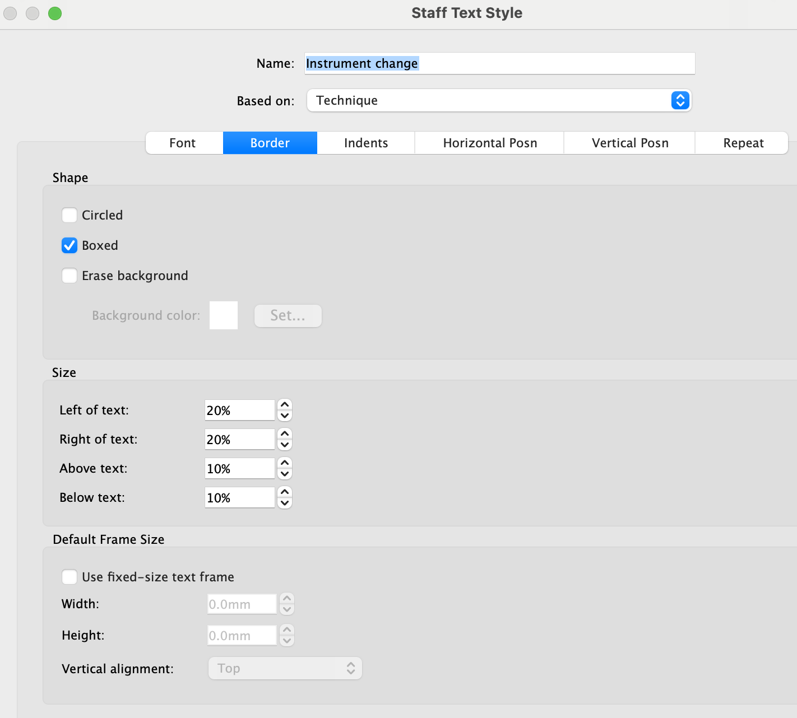

Additionally, if the composer didn’t use instruments changes in the first place, you will need to select the bars for which these particular instrument is being used, and just change it to percussion 5 lines (or whatever number of lines is being used). Then you can simply change the instrument name text/abbreviation accordingly.
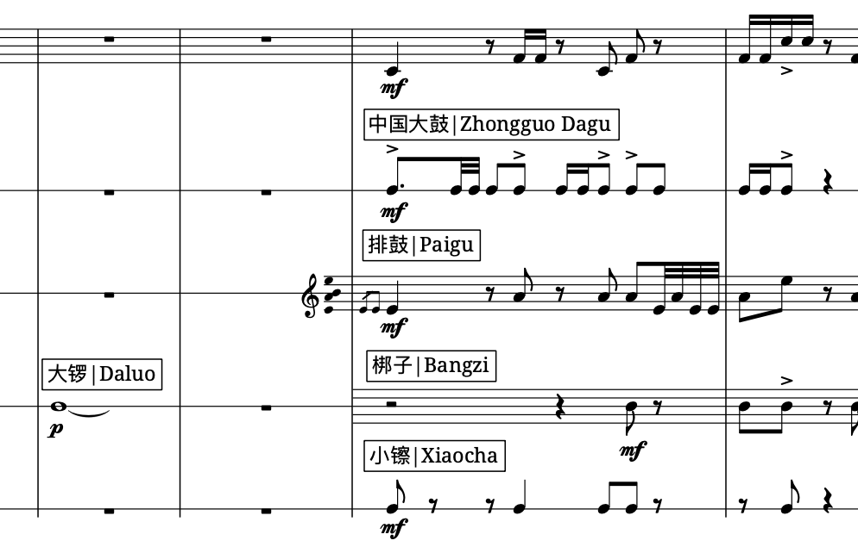
For this boxed text, use the format “Chinese Name | English Name”. Use the full name here.

In the abbreviations, please use the abbreviated formats provided in the other document (Bilingual Chart of Common Chinese Instrument Names). In certain cases of percussion instruments, there may not have an abbreviation, please use the appropriate translation or check with me for the translation if unsure.

Other text styles
Any other text styles not referred here can be checked in the 6th piece. (The Capriccio of the Mountain Folk Song).

